R081: Mood boards and Visualisation Diagrams

Name:

|  |  |  |
| --- | --- | --- |
| **A** | | **Mood boards: Content** |
| 1 | **Images** | |
| 2 | **Colours** | |
| 3 | **Colour schemes** | |
| 4 | **Fonts** | |
| 5 | ***Graphics*** | |
| 6 | *(digital only)* **Sound** | |
| 7 | *(digital only)* **Video** | |
| 8 | *(physical only)* **Fabrics** | |
| 9 | *(physical only)* **Materials** | |

|  |  |
| --- | --- |
| **B** | **Mood boards: Purpose** |
| 1 | *Generation* of ideas |
| 2 | *Development* of ideas |
| 3 | Communication of ideas with clients or colleagues |
| 4 | Creating a mood or feel |

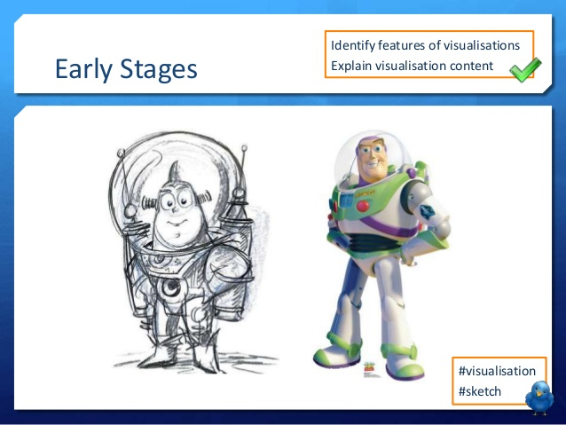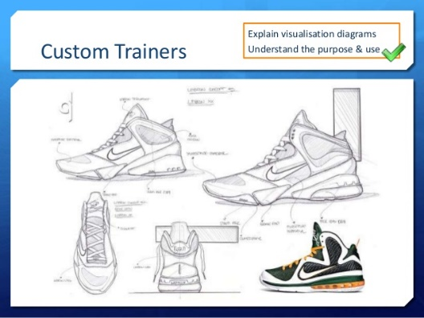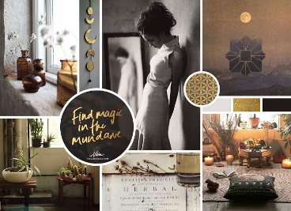

|  |  |  |
| --- | --- | --- |
| **D** | | **Visualisation Diagrams: Content** |
| 1 | **Drawn images** | |
| 2 | **Different viewpoints** (eg bird’s eye, plan etc) | |
| 3 | **Graphics** (eg logos, barcodes etc) | |
| 4 | **Layout** | |
| 5 | **Font** and style of text (not necessarily the content) | |
| 6 | **Annotations** showing details (eg size, interactivities, colours etc) | |

|  |  |  |
| --- | --- | --- |
| **F** | **Visualisation Diagrams: Key Vocab** | |
| **Graphics** | | Images made of simple shapes and colours |
| **Layout** | | The way parts of something are arranged |
| **Interactivity** | | The way something reacts with something else (eg what a button would do on a webpage) |

|  |  |
| --- | --- |
| **E** | **Visualisation Diagrams: Purpose** |
| 1 | Show how a finished item may look |
| 2 | Plan layout of a product visually |
| 3 | Show actions or interactivity |

|  |  |  |
| --- | --- | --- |
| **C** | **Mood boards: Key Vocab** | |
| **Generation** | | Creation |
| **Development** | | Gradual improvements |
| **Physical** | | On paper |
| **Digital** | | On screen |

R081: Mood boards and Visualisation Diagrams

Name:

|  |  |  |
| --- | --- | --- |
| **A** | | **Mood boards: Content** |
| 1 | **Images** | |
| 2 | **Colours** | |
| 3 | **Colour schemes** | |
| 4 | **Fonts** | |
| 5 | ***Graphics*** | |
| 6 | *(digital only)* **Sound** | |
| 7 | *(digital only)* **Video** | |
| 8 | *(physical only)* **Fabrics** | |
| 9 | *(physical only)* **Materials** | |

|  |  |
| --- | --- |
| **B** | **Mood boards: Purpose** |
| 1 | *Generation* of ideas |
| 2 | *Development* of ideas |
| 3 | Communication of ideas with clients or colleagues |
| 4 | Creating a mood or feel |



|  |  |  |
| --- | --- | --- |
| **D** | | **Visualisation Diagrams: Content** |
| 1 | **Drawn images** | |
| 2 | **Different viewpoints** (eg bird’s eye, plan etc) | |
| 3 | **Graphics** (eg logos, barcodes etc) | |
| 4 | **Layout** | |
| 5 | **Font** and style of text (not necessarily the content) | |
| 6 | **Annotations** showing details (eg size, interactivities, colours etc) | |

|  |  |  |
| --- | --- | --- |
| **F** | **Visualisation Diagrams: Key Vocab** | |
| **Graphics** | | Images made of simple shapes and colours |
| **Layout** | | The way parts of something are arranged |
| **Interactivity** | | The way something reacts with something else (eg what a button would do on a webpage) |

|  |  |
| --- | --- |
| **E** | **Visualisation Diagrams: Purpose** |
| 1 | Show how a finished item may look |
| 2 | Plan layout of a product visually |
| 3 | Show actions or interactivity |

|  |  |  |
| --- | --- | --- |
| **C** | **Mood boards: Key Vocab** | |
| **Generation** | | Creation |
| **Development** | | Gradual improvements |
| **Physical** | | On paper |
| **Digital** | | On screen |